1. Scope of Application This standard applies to the configuration and specifications, functions, packaging, transportation, and other items of a comprehensive preventive diagnostic system installed and operated to continuously monitor the operating status of the GIS and transformers within the substation and to analyze and diagnose any abnormalities. Other matters not specified in this standard will be determined according to international standards such as IEC and KEPCO regulations.

IEC 60270 (2000) High-voltage test techniques - Partial discharge measurement IEC 61169-16 Radio-frequency connectors - Part 16 : Sectional specification - RF coaxial connectors with inner diameter of outer conductor 7㎜ with screw coupling - Characteristics impedance 50Ω (75Ω) (Type N) IEC 60529 Degrees of protection provided by enclosures (IP Code) IEC 61850 Communication networks and systems in substations IEC 61850-90-3 Using IEC 61850 for Condition Monitoring Diagnosis and Analysis IEC 60068-2-series Environmental testing(A:Cold, B:Dry heat, Vibration, Damp heat, Cyclic) IEC 61000-4-series Electromagnetic compatibility(EMC) IEC 60255-1(2009) : Measuring relays and protection equipment - Cyclic temperature with humidity test, Damp heat steady state test IEC 60255-5(2000) : Electrical Relays Part5 - Insulation Coordination for measuring relays and protection equipment - Requirement and Test IEC 60255-21-1~3(1988, 1988, 1993) : Vibration, shock, bump and seismic tests on measuring relays and protection equipment IEC 60255-26 (2013) : Measuring relays and protection equipment - Part 26 : Electromagnetic compatibility requirements CICRE TF 15/33.03.05 Partial discharge detection system for GIS : Sensitivity verification for the UHF method and the Acoustic method(1999) IEC 60947-5-2 Low Voltage Switchgear and Control Gear, Part 5 : Control Circuit Devices and Switching Elements, Section 2 : Proximity Switches (2007)

2. Definition of Terms

2.1 Substation Comprehensive Preventive Diagnosis System

This system acquires signals generated from the GIS and transformers within the substation through sensors, processes the digital signals via a Local Unit, and transmits them to a Diagnostic Unit. The Diagnostic Unit utilizes algorithms to monitor, analyze, and diagnose issues concerning partial discharge of GIS, circuit breaker operation characteristics, partial discharge of transformers, dissolved gas detection, OLTC monitoring, and bushings leakage current, while it sends data deemed to indicate abnormalities and important monitoring data to the HMI and the central analysis center. It consists of sensors, a Local Unit, and a Diagnostic Unit.

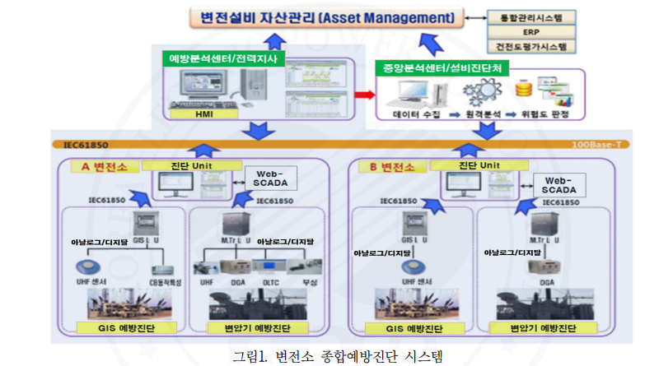

2.1.1 GIS Preventive Diagnosis

Signals such as GIS partial discharge and circuit breaker operation characteristics are acquired through sensors to comprehensively monitor, analyze, and diagnose the GIS status.

2.1.2 Transformer Preventive Diagnosis

Signals such as transformer partial discharge, insulating gas detection, OLTC monitoring, and bushing leakage current are acquired through sensors to comprehensively monitor, analyze, and diagnose the transformer status.

2.1.3 HMI Preventive Analysis Center

It is installed at the unit level, continuously monitoring abnormal signal indicators and important data from the diagnosis units of each substation, detecting anomalies in power equipment based on the absolute values or changing trends of the data, generating alarms, and providing a Web Link function to access the data of the diagnosis unit if necessary.

2.1.4 Diagnostic Unit:

It is a piece of equipment equipped with software that diagnoses partial discharges of GIS and transformers, circuit breaker operating characteristics, the gas inside transformers, OLTC monitoring, bushing leakage currents, etc. It comprehensively diagnoses and analyzes the acquired data converted into digital values at the Local Unit and the information received from Web SCADA, deriving results and providing information to the higher-level HMI and central analysis center, functioning as a web server.

2.1.5 Local Unit:

This unit equipment performs the role of converting signals acquired from sensors into standardized data and sends the data acquired from various sensors to the diagnostic unit. It consists of a Data Acquisition Unit (DAU) that processes the acquired data and a Communication Unit (CU) that transmits the data according to IEC 61850 standards, and it is divided into GIS Local Unit (GLU) and M.Tr Local Unit (MLU).

2.1.6 Diagnostic Software:

This software analyzes data detected through the Local Unit and Web SCADA data for diagnosis, having algorithms for diagnosing monitoring items of transformers and GIS as well as the interrelation between items. It performs the function of continuously monitoring the operational state and determining whether there are any abnormalities internally.

2.2 The Central Analysis Center

The preventive diagnosis system currently operating at all business sites will be installed and operated at the equipment diagnosis department so that it can be managed as a single integrated system. It will monitor and analyze events and critical data obtained from the diagnosis unit, and optimize the management of the judgment algorithm of the diagnosis unit. In the future, it will operate systems for anomaly judgment of equipment, failure prediction, and asset management.

2.3 Prevention Analysis Center

It is installed at the level of power substations or instantaneous supply stations, and performs the function of monitoring and analyzing events and important data obtained from the diagnosis unit, as well as requesting maintenance for equipment where abnormalities have occurred to the relevant department.

3. Performance

3.1 General Information

3.1.1 The equipment (product name) listed in this specification must demonstrate all the functions and performance required by the specification under the conditions set forth in this section.

3.1.2 This system is equipped with sensors that meet the specified performance, and signals sent from various sensors can be transmitted as data to the diagnostic unit via the local unit. It must also support interoperability among heterogeneous (different manufacturers') products between HMI ↔ diagnostic unit ↔ local unit, and perform functions and performance normally.

3.2 Usage Conditions

The system is designed to operate normally under the following conditions.

3.2.1 Elevation: Below 1,000M

3.2.2 Surrounding Temperature

3.2.2.1 Annual Maximum Temperature: Below 40℃

3.2.2.2 Annual Minimum Temperature: Above -25℃

3.3 Considerations for Designing a Comprehensive Preventive Diagnosis System for Substations

3.3.1 Bidders must fully understand the electrical equipment and various conditions of the substation based on the required functions and performance of the comprehensive preventive diagnosis system specified in this specification. The system must be suitable for the characteristics of each device and the surrounding environment.

3.3.2 The system must consider reliability, ease of maintenance, stability, scalability, and compatibility. 3.3.3 All electronic components that make up this device must not be damaged by overvoltage occurring in the substation and must maintain the specified performance.

3.3.4 The functions and performance of all equipment and programs must be equal to or greater than the levels specified in this specification, and the latest technologies must be reflected to ensure the overall performance of the system and complete execution of tasks.

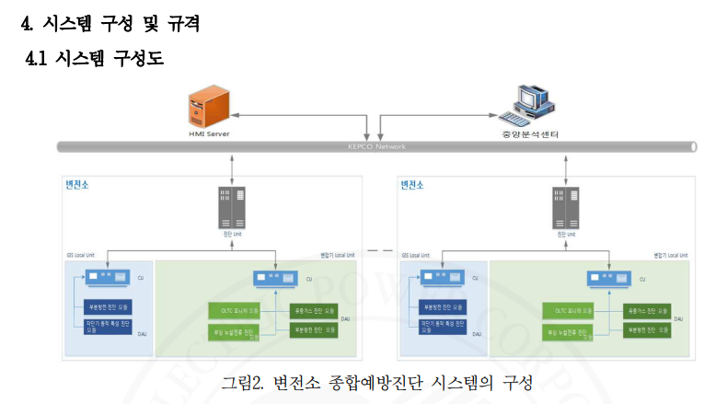

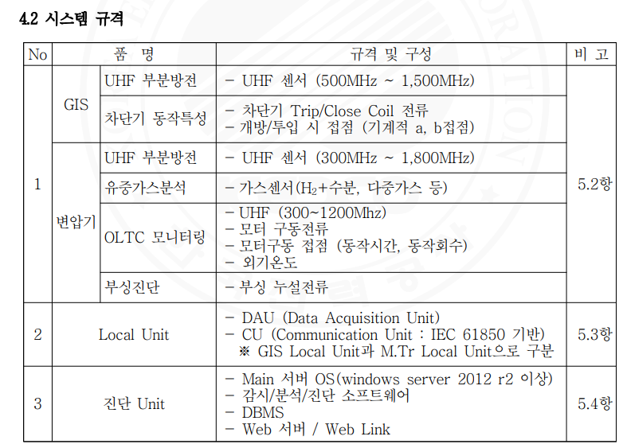

1) Additional reflections may be included based on future diagnostic factor technology development and product pilot operation results.

2) When adding diagnostic items, it should be a compatible structure and should not affect the system's performance.

5. The main components for the comprehensive preventive diagnostic system for substations are as follows.

The specifications and requirements for each diagnostic sensor, local unit, and diagnostic software shall follow the general purchasing specifications of KEPCO unless otherwise specified for each technology.

5.1 Applied sensors The sensors applied to GIS and transformers will follow KEPCO's general purchasing specifications for each technology.

5.2 Sensor requirements The sensor requirements for GIS and transformers will also follow KEPCO's general purchasing specifications for each technology.

5.2.1 Outdoor thermometer

5.2.1.1 It must measure outdoor temperature to be used for temperature compensation of other diagnostic items.

5.2.1.2 The measurement range is based on -25℃ to 40℃.

5.2.1.3 The temperature data shall be output as an analog or digital signal of 4-20 mA.

5.3 Local Unit

5.3.1 The Local Unit consists of a DAU (Data Acquisition Unit) that acquires and processes signals detected by sensors, and a CU (Communication Unit) that transmits the acquired information to the upper diagnostic Unit. However, the CU and DAU can be installed either integrated or separately.

5.3.2 The configuration of the Local Unit should be optimized considering the configuration of GIS and transformers, the number of sensors, signal attenuation, etc.

5.3.3 The enclosure material of the Local Unit should be made of SUS material with a thickness of 2.0 mm or more.

5.3.4 The detection module of the DAU must have the following functionalities:

5.3.4.1 The module must have the ability to transmit detection results to the upper level in real-time.

5.3.4.2 It must have a separate Serial communication port for the analysis of detection results and maintenance.

5.3.4.3 The module must be capable of self-testing and self-diagnosis for sensors, electronic components, and driving software, and in case of a fault, it must output an alarm to the upper diagnostic Unit.

5.3.4.4 The detection device must meet the standards for EMI and EMC.

5.3.4.5 A proprietary precision analysis program from the manufacturer of the detection device should be provided, and the provided program should operate on the latest version of Windows OS.

5.3.4.6 The supply power for the DAU is AC single-phase 220V, 60Hz.

5.3.4.7 The front of the DAU must be able to confirm the normal operation of power, communication, and data acquisition functions through LED lamps or LCD screen displays.

5.3.4.8 The communication module receives information through Ethernet, RS-232, and RS-485 communication, and must be equipped with four or more general-purpose communication ports.

5.3.4.9 The acquired signals from all sensors connected to the DAU are transmitted to the diagnostic unit synchronized with the power phase and time within the substation.

5.3.5 The necessary sensor modules should be appropriately configured according to the type of substation and voltage rating.

5.3.6 The Local Unit is classified into the Local Unit for GIS (GLU) and the Local Unit for transformers (MLU).

5.3.6.1 GLU plays the role of acquiring and processing the circuit breaker operation characteristics and UHF partial discharge measurement signals to transmit them to the diagnostic unit, optimally configured considering the number of circuit breakers, the number of sensors, signal attenuation, location, etc.

5.3.6.2 MLU functions to acquire and process signals for partial discharge measurement, gas-in-oil detection, OLTC monitoring, and bushing leakage current sensors to transmit them to the diagnostic unit, optimally configured considering the number of transformers, the number of sensors, signal attenuation, location, etc.

5.3.7 If the optimal arrangement results for the entire configuration show that IED (Intelligent Electronic Device) is more economical than GLU and MLU, it can be applied as IED.

5.3.8 The configuration of the GLU's DAU is as follows:

5.3.8.1 The GIS partial discharge diagnostic module must be equipped with the capability to detect partial discharge signals from the UHF sensor.

5.3.8.2 The circuit breaker operation characteristic diagnostic module is equipped with the function of measuring Trip/Close contact signals and Trip/Close Coil operating currents to detect operating characteristics.

5.3.8.3 Each module can be integrated and operated together if necessary.

5.3.8.4 The number of sensor connections per BAY should be installed according to the table below, but the optimal number of GLUs should be installed to ensure that the sensitivity of the sensors does not decrease.

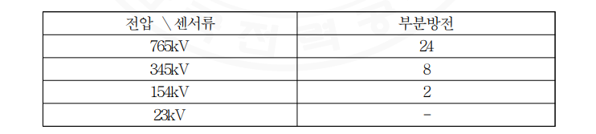

※ The specifications for 765kV and 345kV are based on 3CB standards, while those for 154kV and 23kV are based on 1CB standards, and the detailed configuration for the quantities mentioned above was calculated by referring to the basic sensor configuration plan for each GIS Bay in Attachment 1. The DAU configuration of 5.3.9 MLU is as follows.

5.3.9.1 The UHF partial discharge diagnostic module for transformers must be capable of detecting partial discharge signals from the transformer UHF sensors.

5.3.9.2 The bushing leakage current diagnostic module must have the function of detecting the condition of the bushing (such as leakage current).

5.3.9.3 The OLTC monitoring module must have the function of detecting the motor-driven current and operating time of the OLTC.

5.3.9.4 The dissolved gas diagnostic module must have the function of detecting the dissolved gases in the transformer insulation oil.

5.3.9.5 The number of sensors connected per bank should be installed according to the table below, ensuring optimal MLU quantity to prevent the sensitivity of the sensors from degrading.

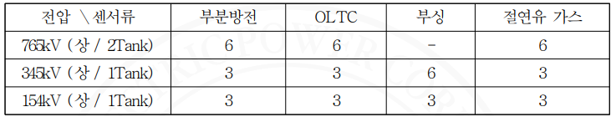

※ The MLU of the transformer is based on the bank unit, and the detailed composition of the quantities above has been calculated with reference to the basic sensor configuration for each transformer bank in Attachment 1.

5.3.10 Detailed Composition and Requirements of DAU for GLU

5.3.10.1 The DAU must be able to set the detection area according to the characteristics of the input sensors.

5.3.10.2 The GIS partial discharge detection module is a device that detects partial discharge signals from the UHF partial discharge detection sensor of the GIS.

(1) Noise Channels must be installed on the DAU for 154kV with 6 Bays outdoors and 12 Bays indoors, and for 345kV with 3 Bays outdoors and 6 Bays indoors.

(2) The signal line connection between the DAU and the partial discharge sensors must follow the KEPCO standard purchase specification 'GIS Partial Discharge Diagnosis System.'

5.3.10.3 The circuit breaker operation characteristic diagnosis module is a device that measures the current of the Trip/Close Coil to detect operational characteristics, following the KEPCO standard purchase specification 'Circuit Breaker Operation Characteristic Analysis Device.'

5.3.11 Detailed composition and requirements of MLU's DAU

5.3.11.1 The DAU must be able to set detection areas suitable for the characteristics of the input sensors.

5.3.11.2 The oil-dissolved gas diagnostic module must

(1) display the concentration of the detected gas in parts per million (ppm).

(2) The type of analytical gas and the detection range must comply with the Korea Electric Power Corporation's general procurement specifications for 'Transformer Oil Dissolved Gas Analysis Device'.

(3) The detection cycle should be within 1 time every 2 hours, and there should be a feature that allows the user to adjust the analysis cycle in hourly units.

5.3.11.3 The signal line connection between the DAU and the partial discharge sensor in the transformer partial discharge diagnosis module follows the general purchasing specifications for transformer partial discharge diagnosis systems.

5.3.11.4 The requirements for the input signal of the bushing leakage current diagnosis module adhere to the general purchasing specifications for the transformer bushing leakage current monitoring device.

5.3.11.5 The requirements for the OLTC monitoring module follow the general purchasing specifications for the transformer OLTC diagnosis system.

5.3.12 Data communication device (CU, Communication Unit)

5.3.12.1 The CU communicates with the DAU (Data Acquisition Unit) connected to the field sensors to acquire information and perform the function of transmitting the acquired information to the diagnosis Unit.

5.3.12.2 The front of the CU must allow for external confirmation of data acquisition and communication status.

5.3.12.3 Communication between the CU and the diagnosis Unit: (1) The communication between the CU and the diagnosis Unit must be configured to comply with the IEC 61850 standard to ensure the continuity of long-term accumulated data, separate data collection and analysis, and facilitate smooth data exchange of measurement results. (2) The communication data must apply a standard data format compliant with the IEC 61850 standard defined in Annex 3, ensuring smooth transmission and reception between heterogeneous diagnosis Units. (3) Communication between the CU and the diagnosis Unit should be structured using Radial optical communication.

5.4 Diagnostic Unit Requirements

The diagnostic unit must have the following functionalities: system control and operation, individual device power control for devices that compose the system, synchronization with the voltages where sensors are installed, self-diagnosis functionality, watchdog, data display, data storage (for a minimum of 1 year), various records of all devices (operations, controls, remote access logging), real-time alarm data, history of anomaly signals, transmission of information such as detected signal data and system operating status.

5.4.1 Hardware Performance

5.4.1.1 CPU: Quad-core or higher

5.4.1.2 Main Memory: 64 GByte or higher

5.3.1.3 Hard Disk: Dual-mode mirroring with minimum data storage capability for more than 1 year (Notification of back-up timing)

5.4.2 The diagnostic unit must be installed with an uninterruptible power supply (UPS) that provides a stable power supply with a backup time of more than 30 minutes, and the power consumption of each device connected to the diagnostic server via the UPS must be specified. Additionally, it must allow for recognition on the HMI during UPS operation, and have the functionality to send alarms to the SCADA system.

5.4.3 The diagnostic unit must detect abnormal conditions such as device anomalies determined from various sensors, network anomalies, data communication device anomalies, local unit anomalies, watchdog operation, etc., and it must implement an alarm function so that it can be recognized on the HMI, and this must be stored.

5.4.4 The operating software, diagnostic software, and web link of the diagnostic unit must be in a user-friendly and convenient latest environment of Korean Windows Server 2012 R2 or higher.

5.4.5 Diagnostic software

5.4.5.1 GIS Partial Discharge Diagnosis

The GIS partial discharge diagnosis system must follow the general purchase specifications and implement equal or higher standards.

5.4.5.2 Circuit Breaker Operating Characteristics Diagnosis The circuit breaker operating characteristics analysis device must follow the general purchase specifications and implement equal or higher standards.

5.4.5.3 Oil Dissolved Gas Diagnosis The transformer oil dissolved gas analysis device must follow the general purchase specifications and implement equal or higher standards. (a) The diagnostic software must monitor and diagnose anomalies inside the transformer using data obtained from the hydrogen or multi-gas and moisture values generated inside the transformer from the dissolved gas sensor signals, and the result types of the analysis must be presented in the system operation manual upon delivery. (b) There must be a function to convert absolute humidity (g/㎥) to relative humidity (%). (c) Continuous data acquisition information should enable trend analysis and comparative analysis by transformer phase or bank, with alarms triggered upon reaching set threshold and trend threshold values; the threshold values must be presented in the system operation manual upon delivery. (d) The output signal of the device must use Ethernet or 4-20 mA analog signal communication methods.

5.4.5.4 Transformer Partial Discharge Diagnosis The transformer partial discharge diagnosis system must follow the general purchase specifications and implement equal or higher standards.

5.4.5.5 Bushing leakage current diagnosis Transformer bushing leakage current monitoring device must follow general purchasing specifications and implement equal or higher standards. (1) The measured data for each bushing must be represented as a vector diagram showing the magnitude and phase of the current, and there should be an algorithm for comparative analysis.

5.4.5.6 Transformer OLTC diagnosis The surrounding transformer OLTC diagnosis system must also follow general purchasing specifications and implement equal or higher standards.

5.4.6 Web SCADA Information Linking and Diagnosis

5.4.6.1 It should be possible to receive substation operational information (such as voltage, load current, transformer winding, and tap position) from the Web SCADA.

5.4.6.2 The data acquisition cycle should be based on once every 5 minutes.

5.4.6.3 An algorithm should be in place to analyze and diagnose equipment status using substation operation information. (1) The transformer status analysis algorithm should include comparative analysis of the relationship between load and temperature (such as load current, internal temperature, external temperature, etc.). (2) The circuit breaker status analysis algorithm should analyze the relationship between voltage, load current, operating time, and temperature. (3) Detailed contents of the status analysis algorithm and analysis cases should be presented in the system operation manual provided at delivery.

5.4.7 Operating Software

5.4.7.1 In-service Operation Features (1) The diagnostic unit should allow monitoring, reference analysis, diagnosis of each preventive diagnostic element of transformers and GIS, and setting of events and alarms for each sensor, with the operating instructions provided in the system operation manual upon delivery. Additionally, it should include a user information recording function when setting reference thresholds and a remote access log authority function. (2) Faults such as communication abnormalities and system malfunctions should be recorded in the system's self-diagnosis results. (3) The local unit and sensor positions should be intuitively displayed on the substation single-line diagram, making it easy for operators to identify the positions of related equipment and sensors by T/L name, transformer name, Bay name, etc. (4) Alarm data should be accessible through the diagnostic unit's monitor for history inquiries and should include a report printing function. (5) All data should be automatically backed up to a separate storage device.

5.4.7.2 Comprehensive Screen Display Configuration (1) All data should be able to be displayed in real-time, categorized by substation, transformer, GIS, and sensor. (2) All operations performed by the user via keyboard and mouse should be displayed in real-time on the monitor.

(3) The screen displayed on the monitor should present information in a partial page format from the overall upper screen down to substation, equipment, and sensor levels such that monitoring can occur for each sensor, and it should be able to display the following content.

(a) System diagram and symbolized transformer, GIS drawing

(b) Locations of sensors by surrounding transformer and GIS, as well as the current values and status information of the sensors

(c) Change trends based on event data stored in the database

(d) Recently occurred alarms and events (e) Menus or icons for each page

(4) The main screen is configured as follows:

(a) Current Status Screen ① When clicking on the relevant device on the main monitoring screen, the location of the sensor should be displayed, categorized by diagnostic items. ② The alarm range and threshold values should be displayed as auxiliary data, and the current values obtained from the sensors should be presented in table (Table) format. ③ If the data obtained from the sensor reaches 95-100% of the configured caution level, a 'Caution Proximity Message' should be triggered; if it exceeds this range, an 'Alarm' should be activated. (b) Change Trend Screen ① It should be possible to navigate to screens of the same level by clicking on menus or icons from the current status screen. ② Recent change trend data obtained from sensors for each diagnostic item should be retrievable. ③ Multiple data sets, such as each phase, each tank, and data from each sensor, can be selected and compared simultaneously, and normal, caution, and abnormal statuses should be represented on a graph. ④ Each analytical value should be shown as a maximum value or average value if necessary. ⑤ The analysis results should be visualized in three dimensions and analyzed visually. (c) Comprehensive Trend Analysis Screen ① The comprehensive trend analysis screen should be able to analyze over a long period compared to the change trend screen, with changes represented graphically by hour, day, month, and period. ② Based on long-term analyzed data, prediction information regarding caution levels reached by each sensor should be provided. (d) System Operational Status Screen ① A screen should be constructed to comprehensively monitor the abnormal status of each system component from the sensors installed in the field to the diagnostic Unit. (e) Alarm Screen.

① An alarm should be triggered when the sensor output exceeds the setting value or when the trend changes beyond a certain rate. ② Alarms should be displayed continuously in order of occurrence, up to 200, and should be retrievable using a scrollbar, with a maximum storage of alarm content for up to 1 year. ③ The alarm content must include date information in the format of year/month/day/hour/minute/second, along with judgment result values for each device and sensor. ④ Alarm notifications must be provided in both visible and audible forms. ⑤ The alarm should blink through the sensor icon of the respective device and should not stop until the user acknowledges and resets it. (5) Criteria for identifying abnormal symptoms should be established, and the results of the analysis based on these criteria should be output in a report format, while the system must have the capability to send alarms and event data to the HMI. Users should be able to change settings such as period and frequency. (6) The colors for abnormal symptoms are defined as follows.



(7) The stored event data must be sent to the relevant server selected from the Central Analysis Center or HMI at least once a week to be utilized in future asset management systems.

5.4.7.3 Detailed screen configuration and functions by diagnostic item (1) The display and analysis functions for GIS and transformer partial discharge follow the general procurement specifications of each elemental technology. (2) The display and analysis functions for transformer dissolved gas analysis signals: (a) Current values, previous day's values, and increases from the previous day obtained from the H2 or multi-gas and moisture sensors of each transformer's main transformer must be displayed. (b) The analysis results of dissolved gases for each transformer tank must be represented with stepwise colors. (c) Structures related to transformer winding temperature and other relevant data must be linked to indicate the causes of changes in dissolved gases compared to trends. (d) The criteria for identifying abnormal signs should be established based on the results of the dissolved gas analysis, and diagnostic parameter analysis should be conducted according to these criteria; the analysis results should be reported as a report, and it should have the capability to send alarms and event data to the Central Analysis Center and HMI. (3) The display and analysis functions for circuit breaker operating characteristics follow the general procurement specifications of elemental technologies. (4) Display and analysis function of bushing leakage current measurement signals (a) Bushing leakage current for each transformer tank is expressed as normal or abnormal with numbers and colors. (b) Measured data for each transformer should represent the magnitude and phase of the current in vector diagrams, and there should be analysis functions according to reference values. (c) The level of the signal that triggers the alarms should be adjustable for each bushing. (5) The display and analysis function for OLTC measurement signals follows the general purchase specifications of the elemental technology.

5.5 Database Management Program Requirements 5.5.1 The latest version of a commercial Database Management System (DBMS) must be used and must be equipped with the diagnostic unit and HMI. 5.5.2 Data must be stored based on the set storage cycle for each sensor, and the cycle must be modifiable. 5.5.3 If necessary, designated administrators should be able to directly access the DBMS from the Operating System via SQL programs to perform tasks. 5.5.4 Database editing must be performed without interfering with online operations, and updates after database operations should be easy to manage. 5.5.5 Database editing tasks should be conducted in a question-and-answer manner, with error detection and handling features to prevent errors caused by improper operations. 5.5.6 An auxiliary program capable of backing up stored data must be provided, creating an environment where backups can be saved to auxiliary storage devices at set intervals. 5.5.7 Data stored in the DBMS must be transmitted via MMS according to IEC 61850, allowing for integrated operation with other equipment's preventive diagnostic systems. The structure of the transmitted data refers to Attachment 3, which details the file data structure based on the IEC 61850 standard data format.

5.6 Standardization of Connection Terminals of Components

5.6.1 Connection Between Sensor and Local Unit The connection between the sensor and the Local Unit is made using standard coaxial cables and N-type connectors as specified in sections 4.2.1 and 4.3.2, ensuring compatibility for connections between heterogeneous sensors and the Local Unit (impedance 50Ω).

5.6.2 Connection Between Local Unit and Diagnostic Unit

The communication connection between the Local Unit and the Diagnostic Unit must transmit and receive data in the standard data format specified in IEC 61850, ensuring data compatibility and continuity between heterogeneous systems.

5.6.3 Connection Between Diagnostic Unit and HMI Server

The communication connection between the Diagnostic Unit and the HMI server uses our company's communication network and applies the standard data format based on IEC 61850.

5.7 When installing the diagnostic unit for compatibility with other equipment's preventive diagnostic systems, scalability must be ensured so it can operate comprehensively with other systems such as Web SCADA and a central analysis center in the future. 5.7.1 Diagnostic Unit ↔ Web SCADA: DNP KEPCO 1.0 5.7.2 Diagnostic Unit ↔ HMI, Central Analysis Center: IEC 61850 5.8 Access Rights 5.8.1 This function is intended to maintain security for operational data within the system, allowing the acceptance of operator IDs and passwords (at least 8 characters in alphanumeric) for each grade, which can restrict the scope of system use. 5.8.2 The scope of permissions should be configurable by function and user, and the registration and editing of operator IDs should be performed only by the system administrator (Super User) through the access rights setting screen. 5.8.3 Permissions should be divided into approximately 4 levels, with the highest level being Super User.

6. Testing 6.1 General Testing Information 6.1.1 Recognized tests are conducted to confirm the quality of the product and the manufacturer's quality maintenance capability for the testing and inspection items stipulated in Table 1, and the determination is based on test reports from certified testing organizations recognized by an accreditation body that has signed the mutual recognition agreement of the International Laboratory Accreditation Cooperation (ILAC), or from a KEPCO subsidiary. 6.1.2 Acceptance tests are conducted as specified in Table 1, only to guarantee the performance recognized during the acceptance testing of the items upon purchase or if required by the user. During acceptance requests, two copies of the test report detailing the test procedure documents, partial discharge functionality, performance verification data, test equipment, testing standards (basis), testing procedures, and test methods must be submitted. Table 1. Testing and Inspection Items

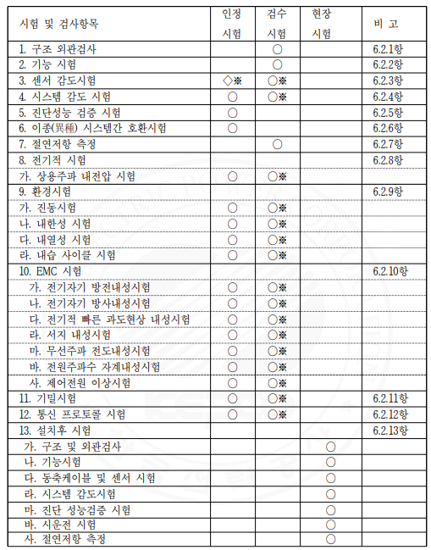

The certification test for sensor sensitivity (items marked with ◇※) is based on the test report conducted by our company's affiliated organization, and the items marked with “※” (items 3, 8, 9, 10, 11, 12) will be replaced by the certified test report. 6.1.3 The field test is a procedure to confirm the occurrence of abnormalities after transporting and installing the products that have passed the inspection test, which includes the commissioning test. 6.1.4 The diagnostic unit is excluded from electrical tests, environmental tests, and EMC test items.

6.2 Test Methods 6.2.1 Structure and Appearance Inspection Inspect each component's structure and appearance to verify compliance with this specification, item by item, and against approved drawings. 6.2.2 Functional Testing Test the functionality of the entire system and each part, with the main test items as follows: (1) System Startup and Shutdown (a) OS boot and system startup using power On (b) OS shutdown commanded and system shutdown using power OFF (c) Automatic OS shutdown and system stop due to temporary power outage (d) System startup, OS operation, and normal operation after arbitrary power restoration (2) System Management Functions (3) Network Functions (a) Remote monitoring function using the internal network (b) Event alarm delivery function to the HMI server (4) Sensor Data Acquisition and Processing Function (5) Sensor Data Discrimination and Display Function (6) Event and Trend Display Function (7) Report Generation and Output Function 6.2.3 Sensor Sensitivity Test (when using external sensors) During the sensor sensitivity test, partial discharge follows Section 7.1.1 of KS C 3700 (Sensor Characteristic Testing) or CIGRE TF 15/33.03.05, while other sensors are subject to satisfaction of performance and error as specified. 6.2.4 System Sensitivity Test The system sensitivity test follows Section 7.1.3 of KS C 3700 or CIGRE TF 15/33.03.05 regarding this specification and is confirmed by a certified test report from an accredited testing institution for EMC test items. 6.2.5 Diagnostic Performance Verification Test The diagnostic performance of the diagnostic unit requires that partial discharge be diagnosed through a blind testing method with 20 or more discharge cells and experimental data, achieving an accuracy of 90% or more; other diagnostic performance must meet the performance criteria specified separately during verification tests. 6.2.6 Compatibility Testing Between Different Systems.

(1) The interoperability test between different systems is conducted in accordance with the attached "IEC 61850-based Standard Data Format" to confirm the communication and diagnosis between different Local Units - Diagnosis Units and Diagnosis Units - HMI based on IEC 61850. It generates partial discharge signals for five types of GIS partial discharge (insulation, floating, particle, corona, noise) and partial discharge signals for six types of transformer partial discharge, achieving an accuracy of 80% or higher, and any additional diagnostic performance interoperability tests must meet the specified performance criteria during verification testing. (2) During the initial approval test of a system developed according to this specification, compatibility must be verified for both the priority development company and the two subsequent development companies across all different systems. However, subsequently, the responsibility for verifying compatibility with the priority development company lies with the subsequent development company. 6.2.7 Insulation Resistance Measurement is conducted following the test method specified in IEC60255-5 and must be measured with a 500V DC insulation resistance tester, achieving values greater than those in (Table 6-1).

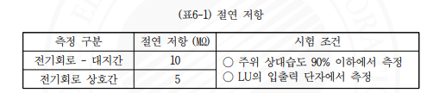

6.2.8 The following electrical tests shall be carried out on the entire electrical testing system. (a) Commercial frequency withstand voltage test The commercial frequency withstand voltage test shall be conducted according to the test methods specified in section 8.3.3.4 of IEC 60947-5-2 or IEC 60950-1, applying the commercial frequency voltage in Table 6-2 between the electrical circuits and ground, among electrical circuits, and between the terminal contacts for 1 minute without any performance failure.

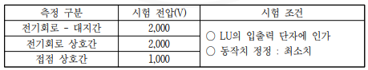

6.2.9 Environmental tests for the LU system shall be conducted as follows: (a) Vibration test The vibration test shall comply with IEC 60068-2-6 (Test Fc: Vibration (sinusoidal)).

(a) The cold resistance test follows IEC 60068-2-1 (Test A: Cold). (b) The heat resistance test follows IEC 60068-2-2 (Test B: Dry heat). (c) The humidity cycling test follows IEC 60068-2-30 (Test Db: Damp heat, cyclic (12 h + 12 h cycle)).

6.2.10 For the entire EMC test system, the control power will be applied under rated conditions to conduct the following EMC tests: (a) Electromagnetic discharge immunity test: This test follows IEC 61000-4-2 (Electrostatic discharge test) and applies test level 2 (metal enclosure, contact discharge, test voltage 4kV, etc.). (b) Electromagnetic radiation immunity test: This test follows IEC 61000-4-3 (Radiated, radio-frequency, electromagnetic field immunity test) and applies test level 2 (minimum electromagnetic field strength 3V/m). (c) Electrical fast transient immunity test: This test follows IEC 61000-4-4 (Electrical fast transient/burst immunity test) and applies test level 2 (minimum test voltage 1kV); however, if the cable length is more than 2m, it applies level 3 (minimum test voltage 2kV). (d) Surge immunity test: The surge immunity voltage follows IEC 61000-4-5 (Surge immunity test) and applies test level 3 (test voltage 2kV). (e) Radio-frequency conducted immunity test: This test follows IEC 61000-4-6 (Immunity to conducted disturbances, induced by radio-frequency field) and applies test level 2 (test voltage 130dBμV). (f) Power frequency magnetic field immunity test: This test follows IEC 61000-4-8 and applies test level 4 (magnetic field strength 300A/m).

(g)Test for abnormal control power (voltage drop, instantaneous power failure, DC power pulsation) is conducted in accordance with IEC 61000-4-11, and the test level applies to Class 2.

6.2.11 Confidential Test The confidential test shall be conducted on the Local Unit casing, following IEC 60529, and must be rated IP54 or higher. 6.2.12 Communication Protocol Test The communication protocol test verifies the compatibility of the protocol between the Local Unit and Diagnostics Unit, as well as between the Diagnostics Unit and HMI, according to the IEC 61850 standard. However, this test item may be recognized through tests conducted by accredited testing institutions and KEPCO affiliates (Power Research Institute). 6.2.13 Post-installation Test (1) Structural and Appearance Inspection: Follow item 6.2.1 (2) Functional Test: Follow item 6.2.3 (3) Coaxial Cable and Sensor Test The coaxial cable test verifies the ability to measure signals stably by installing cables with losses below 4 dB at 1000 MHz, ensuring there are no bends to prevent signal attenuation during cable connections and installation. (4) System Sensitivity Test: Follow item 6.2.4 (5) Diagnostic Performance Verification Test: Follow item 6.2.5 (6) Commissioning Test (a) The commissioning test confirms whether the system can operate normally in an environment where the operator applies the system's functions, after the installation of the system's hardware and software, sensor installation (if external), testing with the Diagnostics Unit-Remote Diagnostic Center and Central Diagnostic Center, and completion of the overall system test. The commissioning testing period lasts for 30 days from the start date, and if errors are found during this period, corrections are made, and after stabilizing the facility, commissioning is repeated for another 30 days from that point. (b) The system availability during the commissioning test period must be more than 99.9% over 30 days (IEEE Std C37.1-1994). (c) Availability formula: Operating time / (Operating time + Downtime) × 100 (%) 1) Operating time: The duration excluding downtime from the total commissioning duration 2) Downtime: The duration of a malfunction state that affects online real-time processing 3) "Does not affect online processing" means that even if some devices in the system fail, it does not stop online processing or shut down the system, as long as the malfunctioning devices are removed.

It refers to cases where repairs or modifications can be made. 4) The commissioning test begins immediately after the completion of the functional and comprehensive adjustment tests, and must be submitted in writing to our company's relevant department one week before the commissioning start date for approval, and any re-execution will follow this procedure. 5) If the contractor determines that stable normal operation is possible, they shall report the completion of the commissioning to our company and terminate the commissioning test upon our company's confirmation. 7. Submission documents at the bidding stage 7.1 Bidders must submit a bid technical specification and pass our company's technical review. 7.2 The documents to be submitted at the bidding must include the bid technical specification, documents corresponding to evaluation items in Appendix 4 "Comprehensive Preventive Diagnostic System Specification Bidding Evaluation Criteria," and the following items: (1) Specifications of supply materials and specifications for each material (2) A comprehensive process plan including design, manufacturing, and testing plans (3) Training plan for users and related personnel (4) Comprehensive specifications and manuals for the Comprehensive Preventive Diagnostic System (The comprehensive specifications for the Comprehensive Preventive Diagnostic System must include the following) (a) Description of the Comprehensive Preventive Diagnostic System (b) System block diagram (c) Structural diagram of devices (systems) categorized by function and block (d) Software-related matters - Summary of functions by application (data acquisition, alarm handling, etc.) - Algorithms for monitoring, analysis, diagnostic programs, and methods for monitoring, analysis, diagnostics - Data format and transmission specifications to upper systems (e) Operator HMI screen menu and sub-menu composition (including sample output for each menu) (f) Methods for inputting, setting, editing, and managing operational data (g) Technical documents on system scalability (including other substation comprehensive preventive diagnostic systems) (h) Technical documents on compatibility between heterogeneous systems (i) Materials regarding diagnostic performance (accuracy) suitability (j) Other materials regarding bidder system characteristics (5) Quality assurance plan (6) List of measuring equipment for data calibration and precise diagnostics (7) Function and performance verification materials for the Comprehensive Preventive Diagnostic System.

The verification materials for the functions and performance of the comprehensive preventive diagnostic system for substations shall submit test reports that specifically state the test equipment, test criteria (basis), test procedures, test methods, etc. for each of the items below. (a) Diagnostic Unit

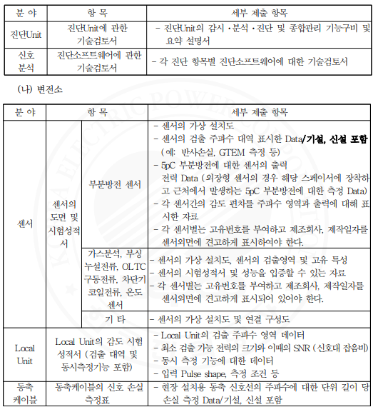

8. Other Matters 8.1 Marking 8.1.1 The name of the device shall be displayed at the top center of the outer front of each device along with our company's logo. 8.1.2 A nameplate containing the following information shall be attached to each device.

○ Equipment model, equipment name, equipment specifications, manufacturing number, manufacturer / Manufacturing date (year, month, day) 8.2 Packaging and transportation 8.2.1 Each device should be securely and stably packaged to protect against electrostatic discharge, vibration, impact, intrusion, etc. during storage and transportation. ○ A packing list is to be prepared in four copies, with two copies included with each device's packaging, and the remaining two copies submitted as documentation. 8.2.2 Transportation: Prior to transportation, the expected shipping and arrival dates and the packing list must be submitted to our company for confirmation. 8.3 Delivery 8.3.1 After production, the inspection procedures stipulated by our company must be completed, and delivery must be made to the designated location. 8.3.2 The supplied software and all operational materials (database, optimized initial settings for the site, etc.) must be completed during the trial operation. 8.3.3 The contractor must submit related drawings, manuals, and SW CDs categorized by device specifications as follows: (1) Drawings by device specifications (a) Layout drawings for each device (b) Connection diagrams between devices (2) Operating manuals (a) Instructions for starting and operating each device (b) Instructions for parameters and input methods for each device (c) Measurement principles for each measurement item (3) Operation and maintenance manual A system operation manual for users and maintenance personnel (distinguished between software and hardware) (a) General guide and user manual for the entire system (b) Basic guide for operating software and detailed settings (c) Basic guide for the software for remote data display and adjustment (d) CD for installation and recovery of operation software and software for remote data display and adjustment (4) Other special notes necessary for system operation and maintenance.

8.4 Installation 8.4.1 The installation will be carried out by the material supplier. (Materials are ordered including installation costs) 8.4.2 The scope of installation includes system installation to comprehensive adjustment testing, and after the hardware installation is completed, adjustment tests on the overall substation comprehensive preventive diagnostic system under online conditions shall be conducted until the debugging work is completed. 8.4.3 After installation is completed, the following as-built drawings that match the installed site should be submitted. (1) Installation layout drawings by device (2) Input power system diagram, various input/output cable wiring diagrams (3) Installation and wiring diagrams of grounding and surge protection devices 8.4.4 Environmental Review Before Installation A noise environment assessment of the substation should be conducted prior to the system installation, and the measured initial data should be used for future analysis of noise environmental changes and noise shielding as well. 8.4.5 Installation will be considered complete upon passing the on-site testing that is subject to testing after installation among the items in the preventive diagnostic system 5.1 "Table 1. Test and Inspection Items". 8.5 Contract Scope and Warranty 8.5.1 Contract Scope (1) The scope of the contract includes the post-management mentioned in 8.6 (upgrades at least once a year, etc.). (2) If certain items are discontinued after the contract is signed or during system production, or if it is determined that a device model can perform better, the installation must be carried out after receiving technical review from our company. 8.5.2 Warranty for Defects The contractor must fulfill the warranty for defects in hardware provided for the system for 36 months from the date of system completion (however, the warranty for software is for 1 year). (1) Defects due to poor system design (2) Defects due to manufacturing flaws and lack of technical skill (3) Defects due to poor selection of raw materials (4) Defects and failures that are not due to KEPCO's mistakes 8.6 Post-Management 8.6.1 The contractor shall conduct on-site inspections of the noise characteristics and impacts of the installed system at the substation and surrounding areas once a year, and submit a report to the relevant office after system upgrades are implemented. 8.6.2 During the warranty period, the contractor will assess the preventive diagnostic system for changes in noise environmental conditions.

In case of an error or the need for a software upgrade due to an operating system (OS) update, immediate action must be taken. 8.6.3 A system optimization operation must be conducted at least once, in conjunction with KEPCO, to verify the operation status before the expiration of the defect warranty period by 3 months, and the results must be submitted to the relevant business office. 9. Training 9.1 Training Content The contractor must provide the following training to our company employees regarding system operation and maintenance, and must provide training materials.

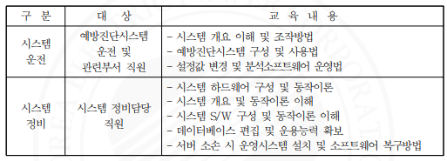

9.2 Educational Costs The educational costs will be fully borne by the contractor, while the accommodation and dispatch costs for the trainees will be covered by our company. 10. Quality Assurance 10.1 The manufacturer must guarantee the quality of equipment through independent quality assurance activities. 10.2 When requested by our company, the relevant quality assurance standard specifications must be followed. Attached: 1. Example of Basic Sensor Configuration by Equipment (GIS, M.tr) 2. Standard Data Format based on IEC 61850 3. Comparison of Data Reference between Diagnostic Unit and HMI, and Software 4. Evaluation Criteria for Bidding on Comprehensive Preventive Diagnostic System Specifications for Substations.

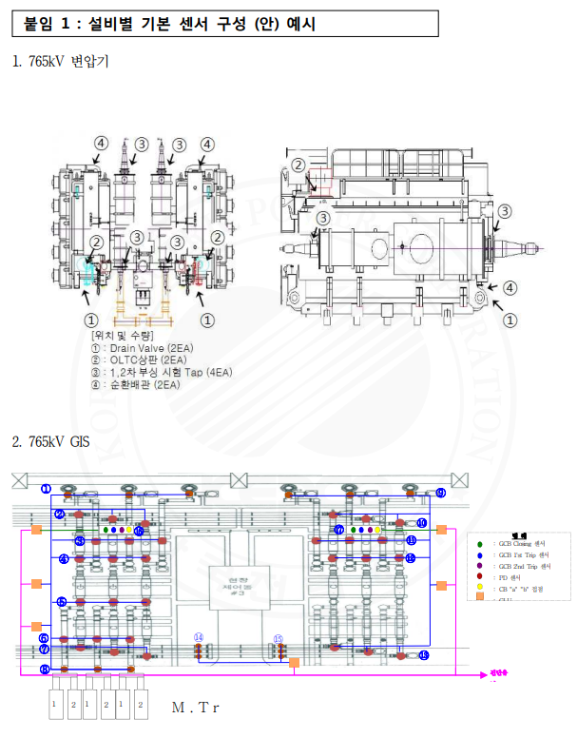

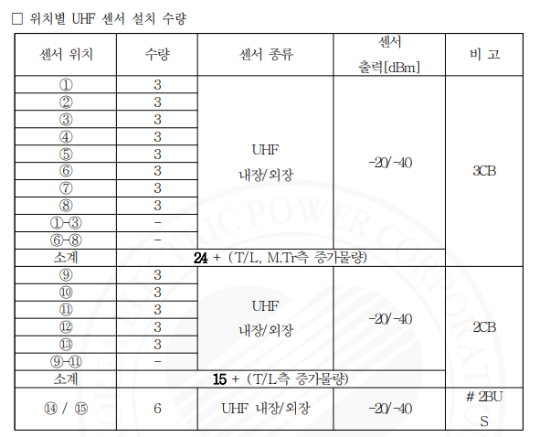

※ Sides ①-③, ⑥-⑧, and ⑨-⑪ may increase the number of UHF as per the GIB span signal attenuation. In particular, in cases where GIB-M.Tr / T/L is a long span, it is designed to sufficiently detect PD signals, and for #2BUS, sensors are installed to the left and right of the upper bus line, and the attenuation rate is calculated based on this to allow for additional installations; for #1BUS, additional installations can be made by calculating the attenuation rate between T/L and T/L. □ Considerations for UHF sensor installation (1) When designing the sensor placement, the output of the built-in UHF sensor is designed based on -20dBm, while the external sensor output is based on -40dBm. (2) The margin for the sensors is designed to ensure that the minimum detection signals for both internal and external sensors are -55dBm. (3) Sensors should be installed to monitor overlapping detection areas to ensure there are no undetected zones.

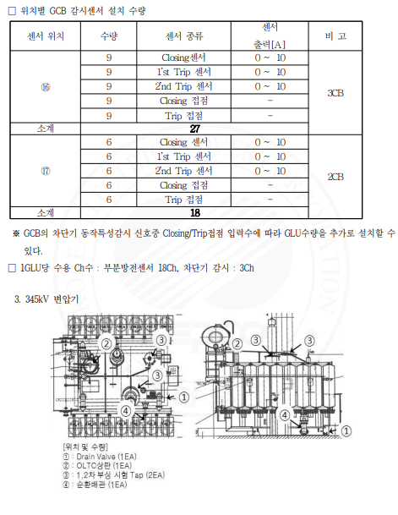

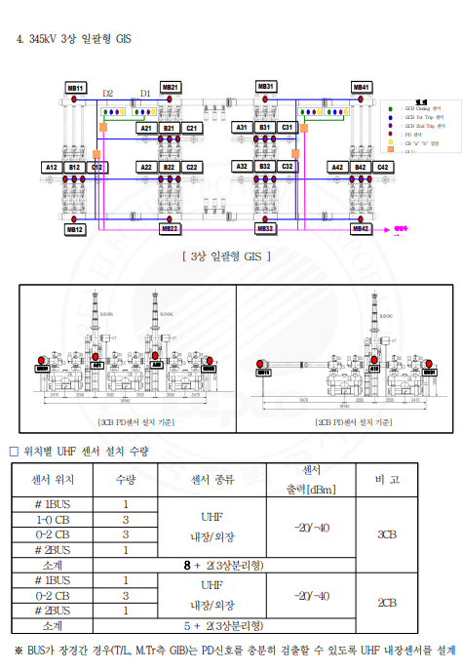

The installation quantity may increase. For the three-phase separation type, additional sensors will be installed on phases A and C to detect PD signals on the #1 and #2 BUS sides in phases A, B, and C. □ Considerations for UHF sensor installation 1. When designing sensor locations, the output of built-in UHF sensors is based on -20dBm, and the output of external sensors is based on -40dBm. 2. The Margin for sensors is designed with a minimum detection signal of -55dBm for both internal and external sensors. 3. Sensors should be installed to monitor overlapping detection areas to ensure that there are no undetected areas.

□ Installation quantity of GCB monitoring sensors by location.

